TT4e
TRANSFORMINGTRANSPORT:FOREVERYONE
TT4E DECLARATION
This declaration is an in-principle reflection on the crises affecting transport in Melbourne and Regional Victoria. Consideration of this document has been through the collaboration of representatives from some of the key transport and planning advocacy groups in the Melbourne region. The communities underpinning many of these groups have been saying increasingly loudly that the planning, delivery and performance of transport in Victoria is not good enough!
The creation of a collaborative entity, Transforming Transport for Everyone (TT4e) stems from the urgent need to tackle the problems and accelerate customer focussed solutions for the Victorian community. Its creation recognised that the power, advocacy and influence of all the key transport and planning advocacy groups is enhanced by collaborating on identified key overlapping areas of mutual interest - to pursue as a united front. However, it is important to note, that each advocacy group will still pursue, independently, its other specific agendas, programs and projects.
This declaration covers:
- Aspirations for Victoria’s transport
- Community Expectations
- Guiding principles to underpin transport planning for everyone, and
- Victorian challenges and priorities
The TT4e Declaration is intended to be an important part of, and underpin, a campaign to transform transport in Victoria for everyone. It is also intended to be a source document when advocating to:
- Federal, state and local politicians
- Federal, state and local government departments and staff
- Industry groups
- Community advocacy groups
- The broader community, and
- The press and other media outlets
The committees of the transport and planning advocacy groups Inner Melbourne Planning Alliance (IMPA), Public Transport Users Association (PTUA), Rail Futures Institute (RFI), Town and Country Planning Association (TCPA), Transport for Melbourne (TfM) and the Victorian Transport Action Group (VTAG) have fully considered this Declaration. The advocacy group committees that, to date, have formally endorsed the declaration have attached their logos to page 2 of the declaration.
The Declaration is contained in the following pages.

Transforming Transport: for Everyone
Introduction
Traffic and transport growth puts pressure on Melbourne degrading its liveability. Melbourne is forecast to reach 8 million by 2046. Without major changes in the way we move people and goods Melbourne will not be liveable. This is a problem faced by Victoria as a whole and requires strong leadership with a set of clear aspirations, expectations and guiding principles for Victoria’s transport.
Aspirations for Victoria’s transport
Transport planning for Victoria’s future is the responsibility of government, not the private sector. Accordingly:

- Victoria’s transport must be benchmarked against world best practice
- Transport planning and service delivery must include the needs of the whole community, especially growth areas and those who are disadvantaged
- No Victorian should be disadvantaged through the inability to own or access motorised private transport

Expectations

Transport planning and administration must be transparent, collaborative, consultative, always in the public interest and aspire to world best practice by:

- Complying with all acts of parliament especially the Victorian Transport Integration Act 2010
- Making publicly available major service agreements and contracts between government and service providers
- Timely publication of patronage, timekeeping and other service information, including performance requirements and remedies for non-performance, collected by government and service providers
- Good governance giving sustainable operations and maintenance of transport infrastructure
- Resourcing and training of transport planners to ensure that transport planning in Victorian is not captured by vested interests.
- Learning from international transport performance standards. and solutions

Guiding Principles

Transport planning must support the movement of people and goods. It will focus on continuous improvement of users’ experiences and explicit service delivery standards. It will drive the most efficient use of resources and infrastructure by ensuring that:
- Planning creates a transport system that is flexible, adaptable in a rapidly changing world
- Transport and land use planning are integrated in ways that ensure continuous modal shift for people movement towards active and public transport and to support the movement of goods on designated freight networks, including rail
- Transport and land use planning integrates national, state-wide, regional and local scales, aimed at all times to
  - Maximise public health benefits
  - Maximise equity of access to markets, jobs, education and services
  - Minimise non-renewable energy use
  - Minimise negative environmental impacts and consequences
  - Maximise the movement of freight on the rail network.

Victoria’s Transport Challenges
We welcome the Victorian Government’s creation of Infrastructure Victoria, Transport for Victoria and the Victorian Planning Authority. However, there are huge problems in our regional cities, towns and across Melbourne’s suburbs that urgently need to be addressed by these agencies for the long-term future quality of life of every Victorian:
- Access to rail and bus services for many towns and cities in Regional Victoria needs dramatic improvement: in many, there is no public transport worthy of the name
- There are no real plans to remove freight trucks from residential streets. Super-heavy trucks are on the drawing boards that are bigger than those that are already carving up our rural roads and bridges. Big roads like the Western Distributor will generate more car travel and will be avoided by the Supply and Logistics sectors whether due to timelines, tolls or congestion
- Freight transport is set to double in the next 20 years. There is no plan to provide for this growth. Victoria needs a plan to reverse the 30-year decline in rail freight with portfolio responsibility. Shifting freight to rail would deliver major road safety benefits and release much-needed road space for those who have no other choices
- 47 years after Melbourne Airport opened; there is still no real plan for an airport rail link. We need an integrated transport plan for the airport – not just for travellers, but as a significant employment and freight centre in its own right
- There is significant traffic congestion on a growing number of Melbourne’s roads and freeways restricting efficient access to jobs, shops and schools. Average commute times are lengthening beyond what most deem reasonable
- The train network is underserviced and crowded and suffers from many generations of neglect. A backlog of maintenance and outdated systems and practices limits our progress. Melbourne Metro Rail and the Level Crossing Removal Project are needed, but far more must be done to capitalise fully on these significant investments and bring our railways into the 21st Century
- Trams are over-crowded and serve less than 25% of Melbourne. Bus routes are extensive, but poorly utilised because service levels and routing are extremely poor – average frequencies of 45 minutes are not viable for most people, while many routes are circuitous. Reform of the bus network is long overdue
- School drop-offs and pick-ups are major sources of road congestion, yet little policy attention is given to safe and healthy alternative ways for children to get to and from school
- Planning of our cities does not involve Victorian citizens in meaningful way, nor does it prioritise public interest. It is captured by sectional interests. Planning must involve the community to standards prescribed by the World Health Organisation and Victorian Transport Integration Act 2010.
Providing alternatives to cars and trucks for everyone will release road space for those who really need it, reduce congestion in the long term and generate improved public health outcomes. Extending the provision of decent public and active transport will transform the incentives for development to better integrate living and working, shopping and recreation. Everyone has an interest in a healthier future with genuine transport choices.

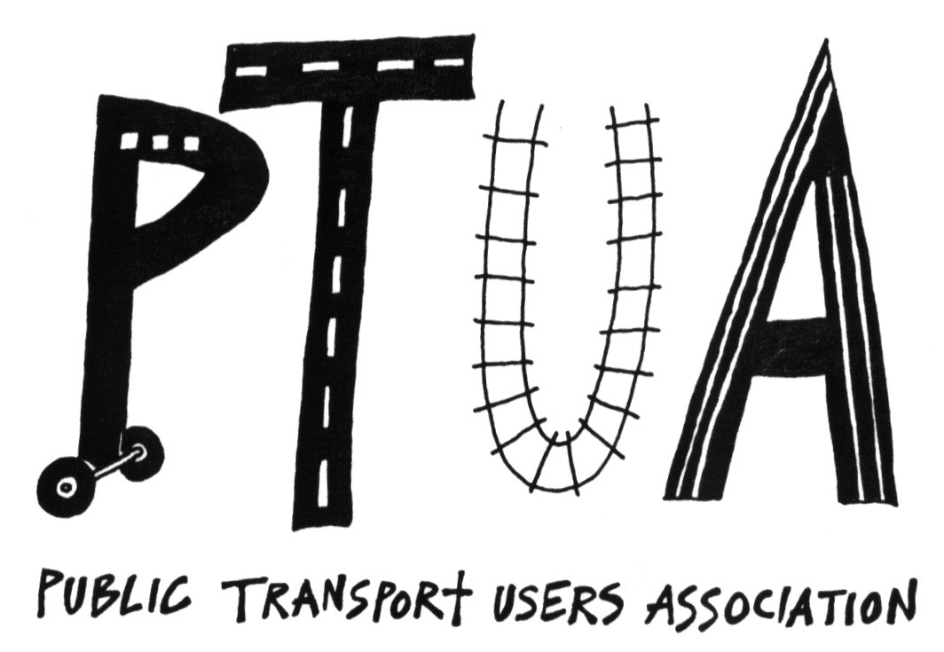
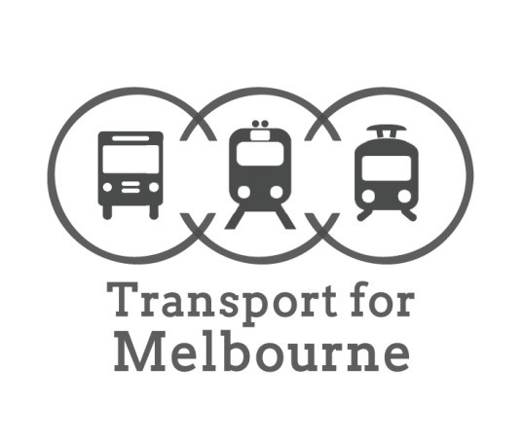
RAIL FUTURES INSTITUTE

